Fall 2018

Anthony Herron and Mahfoudh Batarfi

Bowie State University

Fall 2018

Wildlands: Obstacle Avoidance

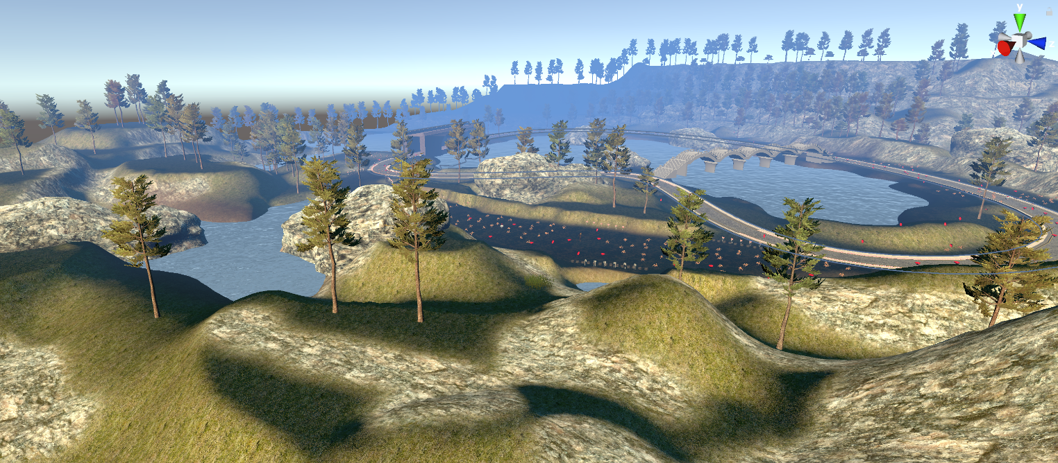

# Goal and Objectives

The objective of this project is to create a game that is easy to pick up and play. The game is supposed to be played mostly for exploring the world rather than completing specific objectives. The goal of this project is to navigate through the wildlands while collecting gems. While navigating through the wildlands, there are multiple enemies trying to kill you.

# Levels

The first level’s purpose is getting used to the game, while the second level is more challenging. The first level’s enemies do very low damage and the health pickups also do very little. There is also more time so you can explore the game. The second level enemies do much more damage and health items give more health. The goal of the game changes to try collect a certain amount of gems within a shorter time limit.

# Modeling

The modeling is based on a woody area that would be similar to other games. The game features gems and hearts as pickups along the map. The gems are collected and stored in a counter for the user to see. Hearts are health items that will restore your health when picked up.

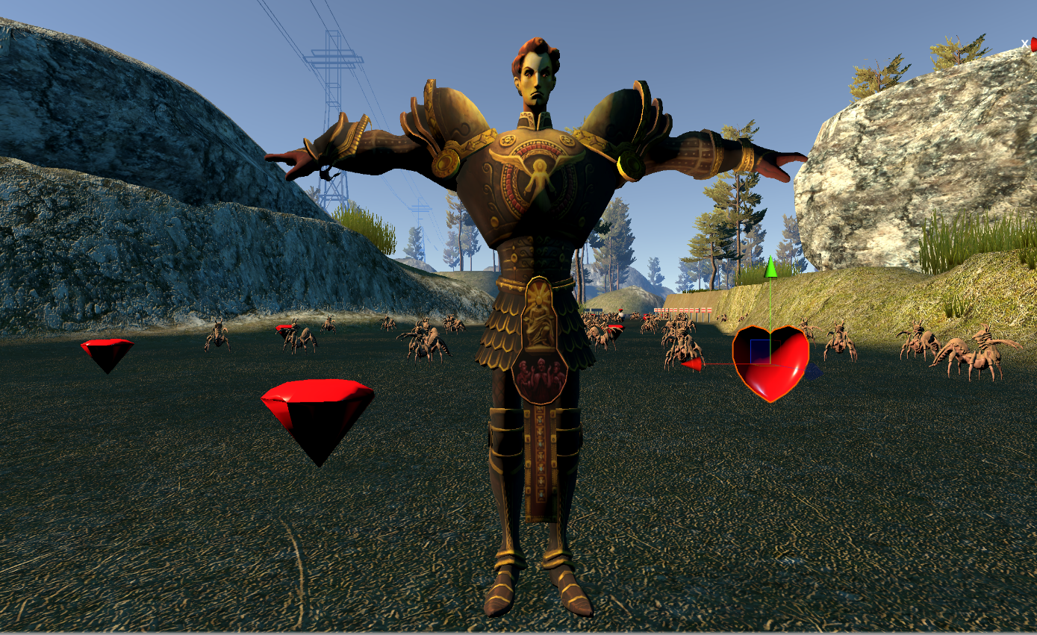

The environment is filled with many bridges, roads, trees, and ponds. There will not be any gems on or in any tree or pond as they are mostly just for show. Roads and bridges are a different case and will be filled with enemies, gems, and health. There are also pedestals that hold up gems, these will usually be surrounded by enemies.

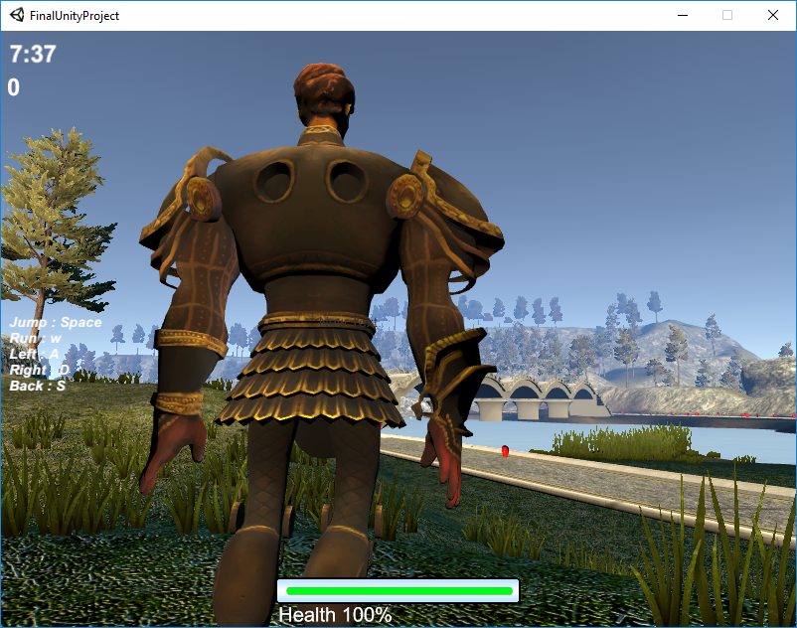

There are plenty of enemies everywhere, especially surrounding gems. The enemies are all different types of spiders. The enemies will try to obstruct the path to the gems while also trying to deal as much damage as possible.

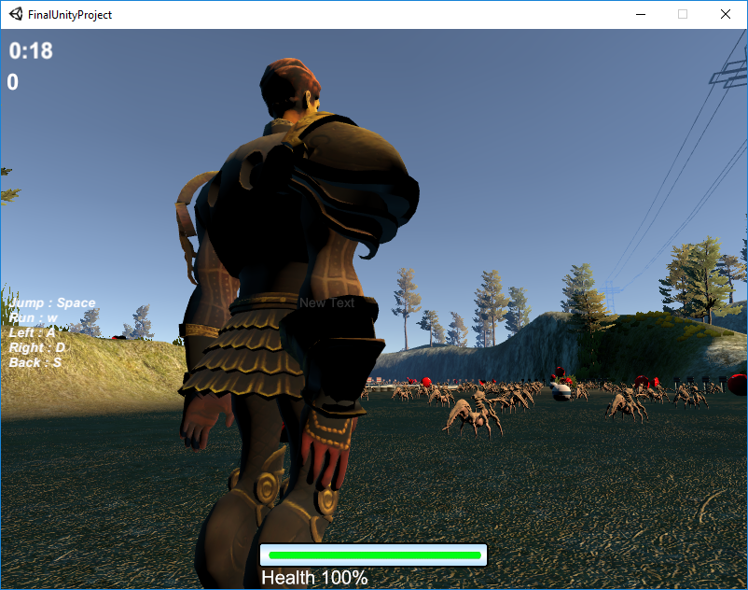

There are also mountains, barricades, phone towers placed around the map which don’t serve a practical purpose. These things are only there for visual effects, but barricades will obstruct the player’s movement.

# Lighting

We added a skybox and sun to the environment in Unity. The sun is visible while playing the game. This way when moving around the world, you can see shadow and shade on objects and the character.

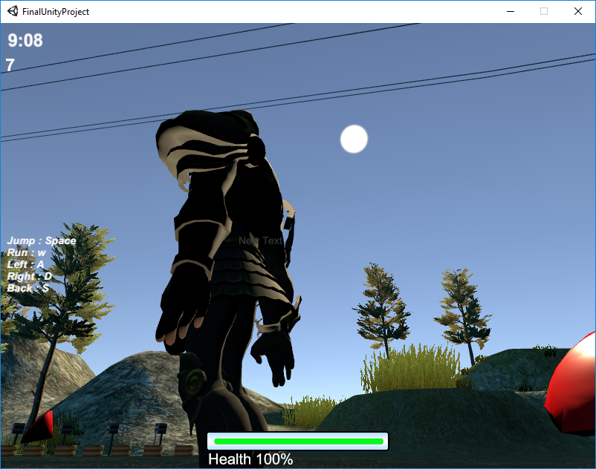

# Sensors

The game is based on collecting gems, so we figured the best thing to do was to use proximity sensors for the enemies. When the player enters the enemy’s proximity, the enemies will start to move towards the enemy. When the player leaves the proximity’s range, the enemies will stop moving. We also have a time sensor to which will let the player know how much time is left. There is also collision detection to make sure the player interacts with the enemies and objects.

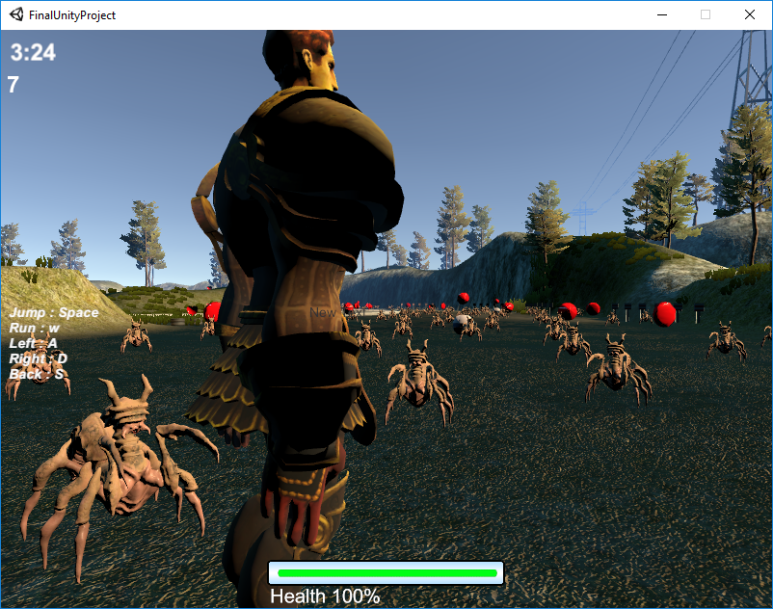

# Animations

The animated objects in this game are the player, enemies, and gems. The player has animations for moving, jumping, and being idle. Enemies will only move towards the player. Gems spin around while also moving up and down.

# Interactivity

The main forms of interactivity in the game deal with collecting items and attacking enemies. The player can collect gems that are scattered across the world and the counter will be updated for each pickup. The player can also pickup health items which will increase your current health percentage. The player can also jump on enemies which will cause the enemy to die.

# Challenges

The hardest part of creating this game is collision detection. We had a hard time making the character actually collide with other object without getting stuck. There are still points where the player can get stuck for a period of time. The player will get out of the situation after some time. Another challenge was making the objects disappear on time. The game couldn’t erase things quick enough for real time, so objects will appear destroyed after a second or two.

# Why Virtual Reality?

Since this was a virtual reality class we wanted to put more emphasis on exploring. We hoped that players would feel more immersed in the game that way. We understood that first person would’ve increased the experience so we added a first person camera. We wanted the player to feel part of the world without the restraint of having doing complete objectives.